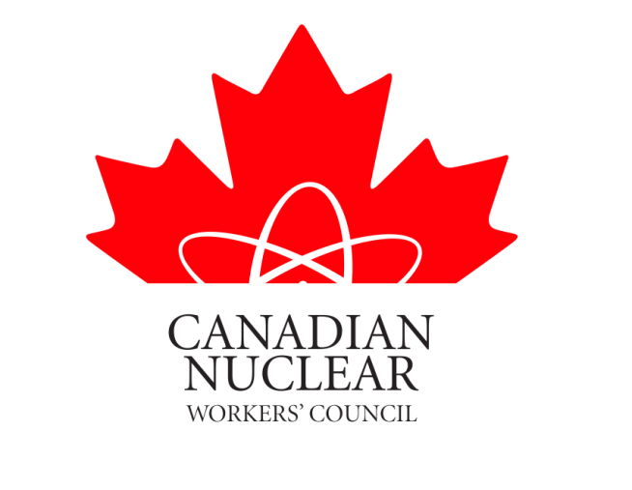

POLICY REGARDING LABOUR LEGISLATION

As the collective voice of Unionized workers in Canada's Nuclear Industry, the Canadian Nuclear Workers' Council‎ unanimously supports our member unions and the positions of general labour organizations in condemning any legislation that undermines the rights of unions, union members and working people in general. This includes, but is not exclusive to, so called "right to work" legislation that is specifically designed to limit the ability of organized labour to advocate on behalf of their members and workers across Canada.

Further, it is the position of the CNWC that a strong a vibrant labour movement always improves the health and safety of workers, workplaces and their communities.

David Shier
President CNWC

February 27, 2014

