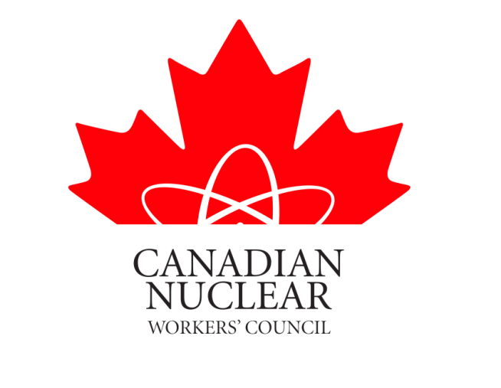

SUBMISSION TO THE
CANADIAN NUCLEAR SAFETY COMMISSION

IN THE MATTER OF

THE APPLICATION BY THE CAMECO CORPORATION FOR THE RENEWAL OF THE OPERATING LICENSE FOR IT’S NUCLEAR FUEL CONVERSION FACILITY LOCATED IN PORT HOPE ONTARIO.

DECEMBER 18, 2011

Members of the Commission:

The Canadian Nuclear Workers Council (CNWC) is an organization that is comprised of Unions that represent workers in Canada’s Nuclear Industry. Appendix 1, attached, states the objectives of the council as well as a list of the Unions that are members of the Council.

The CNWC has reviewed the applications for the license renewal for the Port Hope Nuclear Fuel Conversion Plant located at Port Hope Ontario as well as the CNSC Staff Submission. The CNWC is in full support of having the Operating license renewed for a five year period.

The two United Steel Workers (USW) local unions at the Conversion Facility are long time members of the CNWC and as such keep us well informed of the activities at this facility.

The United Steel Workers (USW) is a Union that takes the Health and Safety of its members very seriously. The USW has spearheaded many Health and Safety campaigns on behalf of their members over the years. This fact hopefully will assure the Commission and the Public that if there were or are in the future any safety concerns at the Cameco Port Hope facility that they would be brought to the attention of the USW and would be addressed promptly.

The workers at Cameco live in Port Hope and the surrounding communities. They are naturally concerned with the environment as well as the health and safety of their families. The USW locals would naturally raise any environmental or health and safety issues, in regards to this plant, where they had concerns.

The CNWC is in full support of the USW local 13173 submission. As can be seen from their submission they have been active in the local community in assuring the public that the operations at Cameco are indeed safe.

The USW local unions at the site are members of the Northumberland & District Labour Council (NDLC). Labour Councils are set up across Canada by the Canadian Labour Congress (CLC). Councils are comprised of unions in the district and their mandate is to ensure that unionized workers views are made known at the municipal level and beyond. Labour Council members are community activist and as such keep informed of issues in their communities. The NDLC hears the views of the small minority of the public that are opposed to the Port Hope Cameco Facilities. The USW is able to provide the NDLC with the true facts of any events that are highlighted by community groups. The NDLC recognizes the Cameco facilities as safe operations and they have made a submission in support of the license renewal.

There are many nuclear workers living in Port Hope and the bordering communities. Many of these workers are employed at the Darlington Nuclear Plant. The CNWC did an informal poll of these citizens and found that they have no concerns with the Cameco, Port Hope operation and are in full support of the relicensing of this facility.

As do all other member organizations of the CNWC, the USW Locals holds health and safety of workers to be paramount. Cameco management and the union have established a very good understanding and a good working relationship. The CNWC fully endorses and supports the very active health and safety culture promoted and established by USW locals and their employer, Cameco. The local Union works closely with Cameco management to establish safety policies and procedures to maintain a safe and healthy workplace and to protect the surrounding natural environment.

The CNWC conducts an annual convention where delegates from the Canadian Nuclear facilities provide updates on their workplaces. The USW locals’ presentations are always very well received. Most of the CNWC Executive members as well as several of the delegates from our member organizations have toured the Cameco Port Hope facility and are in full support of the operation. The plant’s cleanliness and its health and safety record have impressed delegates from other CNWC member organizations who have toured the plant

In 2007 a group of Trade Union Representatives toured the Fuel Conversion Plant. These worker representatives were from the nuclear fuel sector in Argentina. In discussions these people made it very clear that they were very impressed with the Cameco operations and specifically the emphasis on safety and environmental issues. This tour provided us with a different set of eyes viewing these facilities and helped ensure us that the CNWC view that the Fuel Conversion Plant is a safe operation.

Cameco’s operations continue to receive positive community and industry support. The many union members who live in Port Hope receive very positive feedback on Cameco’s efforts within the community. The company maintains communications with the community through participation in various community initiatives and joint committees. These joint committees ensure that any municipal concerns regarding plant operations are expressed to management and dealt with promptly and effectively...

Cameco continues to display a progressive and caring approach towards the health and safety of its workers and protection of the environment. Plant performance continues to be consistently excellent with emission levels well below regulatory levels. The CNWC therefore joins with the USW Locals in supporting the fact that the Cameco Corporation is operating their Port Hope facility in a safe manner and we fully support the renewal of the operating license for the facility.

David Shier
President CNWC

APPENDIX 1

CANADIAN NUCLEAR WORKERS COUNCIL

The Canadian Nuclear Workers Council (CNWC) was founded in 1993 as an umbrella organization of workers who are represented by unions in various sectors of the Canadian nuclear industry.

Purpose of the CNWC

1. To ensure that the views, concerns and interests of nuclear industry workers represented by unions or worker associations are brought to the attention of governments, regulatory authorities, nuclear energy related inquiries, the media, and members of the public.

2. To promote, through dissemination of factual information based on the experience and knowledge of our workers, a better understanding of the social, industrial, and economic benefits of nuclear energy, in particular:

i) its safety, environmental soundness, and economic viability;
ii) its role as a creator of high quality jobs;
iii) its importance to Canada’s industrial competitiveness and exports;
iv) its major contribution towards enhancing Canada’s expertise in science, engineering, technology, and skilled trades.
3. To communicate with and inform Canadian workers in other sectors of the Canadian economy of these benefits of nuclear energy.

Objectives of the CNWC

To carry out its purpose the objectives of Council are to:
i) Maintain and enhance a data base to provide more factual and authoritative information on nuclear issues;
ii) Facilitate a better informed public by providing information on nuclear issues;
Provide a focus to ensure that the interests and perspective of nuclear workers are heard by decision makers;
iii) Strengthen the role of nuclear workers as a partner in their industry;
iv) Gain support for the nuclear industry and its future

Canadian Nuclear Workers’ Council Member Unions

Canadian Union of Public Employees
Locals 957, 1500 & 4250
Communication, Energy & Paper Workers Union

International Association of Firefighters

International Association of Machinist & Aerospace Workers
Local 608
International Brotherhood of Electrical Workers
Power Workers’ Union
Professional Institute of the Public Service of Canada (PIPS)
CRPEG & WRPEG
United Steel Workers
Locals 8914, 7806, 14193, 13713
Chalk River Technicians and Technologist Union
Allied Trades Council (CRL)
Society of Professional Engineers & Associates (AECL)
Hydro Quebec Professional Engineers Union
International Brotherhood of Boilermakers Local 128

