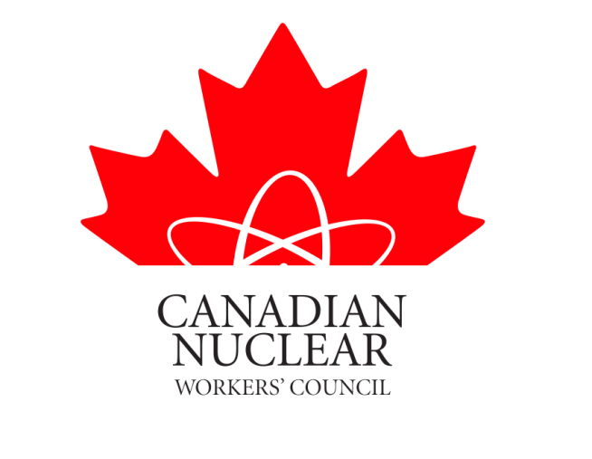

SUBMISSION TO THE
CANADIAN NUCLEAR SAFETY COMMISSION

IN THE MATTER OF

THE APPLICATION BY THE CAMECO CORPORATION FOR THE RENEWAL OF THE OPERATING LICICENSE FOR IT’S FUEL MANUFACTURING FACILITY LOCATED IN PORT HOPE ONTARIO.

DECEMBER 19, 2011

Members of the Commission:

The Canadian Nuclear Workers Council (CNWC) is an organization that is comprised of Unions that represent workers in Canada’s Nuclear Industry. Appendix 1 attached states the objectives of the council as well as a list of the Unions that are members of the Council.

The Union at the Cameco Fuel Manufacturing Plant, the United Steel Workers (USW) Local Union 14193 has been a long standing member of the CNWC.

As do all of the member organizations of the CNWC, USW Local 14193 holds health and safety of workers to be paramount. Management and the union at Cameco continue to have a very good understanding and good working relationship. The CNWC fully endorses and supports the very active health and safety culture promoted and established by USW and Cameco. The Union has worked with Cameco management to establish many safety policies which are in place at the worksite.

The plant Safety Committee consists of both union and management representatives. It meets monthly to address any and all health and safety issues. Monthly meetings well exceed the requirements for the frequency of meetings required under Federal Law for this type of workplace.

During regular CNSC audits of the workplace, union and management representatives from the Safety Committee accompany the Commission inspectors. The Safety Committee has the authority to initiate action, and require a response within specific time limits, on any matter judged by Commission inspectors to require attention and improvement.

Cameco operations continue to receive positive community and industry support. Members of Port Hope City Council and local residents have toured the plant. They have been invariably impressed by the clean and orderly condition of the workplace. Delegates from other CNWC member organizations and representatives from other nuclear industry companies who have toured the plant have been similarly impressed by the plant’s cleanliness and the priority given to worker health and safety.

In 2007 a group of Trade Union Representatives toured the Fuel Manufacturing Facility. These worker representatives were from the nuclear fuel sector in Argentina. In discussions these people made it very clear that they were very impressed with the Cameco operations and specifically the emphasis on safety and environmental issues. This tour provided us with a different set of eyes viewing these facilities and helped ensure us that the CNWC view that the Fuel Manufacturing Plant is a safe operation.

The USW is a union that holds the health and Safety of their members at the top of their agenda. The main Union has taken on several major health, safety and environmental campaigns over the years. This fact alone should assure the public that if there were any unsafe or environmental issues at the facility the USW would be insisting that they were addressed.

The leadership of USW Local 14193 continues to assure the public that the Cameco facility operates in a safe manner and is a great benefit to the community. These workers have appeared before council, met with local and national politicians etc to convey this message.

The workers at this facility live with their families in Port Hope and the surrounding communities. These people would be first to raise the flag if anything arises that had the possibility of harming the health and safety of their families or the environment.

Many residents of Port Hope work at the Darlington Nuclear Power Station which is located to the west of the city. These workers are members of the Power Workers Union (PWU) which is also a member of the CWWC. The CNWC conducted a straw poll of these residents of Port Hope and found them in full support of the relicensing of this facility.

The CNWC supports Cameco’s and the USW’s position that the plant is being operated in a safe manner and in compliance with their operating license. The CNWC is in full support of renewing the Operating License for a ten year period.

David Shier
President CNWC

APPENDIX 1

CANADIAN NUCLEAR WORKERS COUNCIL

The Canadian Nuclear Workers Council (CNWC) was founded in 1993 as an umbrella organization of workers who are represented by unions in various sectors of the Canadian nuclear industry.

Purpose of the CNWC

1. To ensure that the views, concerns and interests of nuclear industry workers represented by unions or worker associations are brought to the attention of governments, regulatory authorities, nuclear energy related inquiries, the media, and members of the public.

2. To promote, through dissemination of factual information based on the experience and knowledge of our workers, a better understanding of the social, industrial, and economic benefits of nuclear energy, in particular:

i) its safety, environmental soundness, and economic viability;
ii) its role as a creator of high quality jobs;
iii) its importance to Canada’s industrial competitiveness and exports;
iv) its major contribution towards enhancing Canada’s expertise in science, engineering, technology, and skilled trades.
3. To communicate with and inform Canadian workers in other sectors of the Canadian economy of these benefits of nuclear energy.

Objectives of the CNWC

To carry out its purpose the objectives of Council are to:
i) Maintain and enhance a data base to provide more factual and authoritative information on nuclear issues;
ii) Facilitate a better informed public by providing information on nuclear issues;
Provide a focus to ensure that the interests and perspective of nuclear workers are heard by decision makers;
iii) Strengthen the role of nuclear workers as a partner in their industry;
iv) Gain support for the nuclear industry and its future

Canadian Nuclear Workers’ Council Member Unions

Canadian Union of Public Employees
Locals 957, 1500 & 4250
Communication, Energy & Paper Workers Union

International Association of Firefighters

International Association of Machinist & Aerospace Workers
Local 608
International Brotherhood of Electrical Workers
Power Workers’ Union
Professional Institute of the Public Service of Canada (PIPS)
CRPEG & WRPEG
United Steel Workers
Locals 8914, 7806, 14193, 13713
Chalk River Technicians and Technologist Union
Allied Trades Council (CRL)
Society of Professional Engineers & Associates (AECL)
Hydro Quebec Professional Engineers Union
International Brotherhood of Boilermakers Local 128

