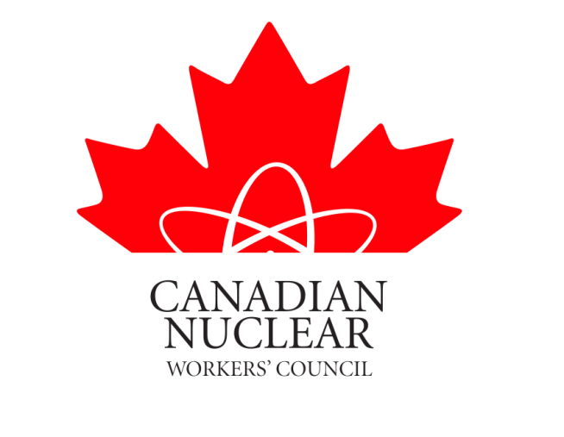

SUBMISSION TO THE

CANADIAN NUCLEAR SAFETY COMMISSION

In the matter of

CNSC Staff Report on the Performance of Uranium
Fuel Cycle and Processing Facilities:
2012

November 15, 2013

CANADIAN NUCLEAR WORKERS COUNCIL

The Canadian Nuclear Workers Council (CNWC) is a council of Unions that have members working in the Canadian Nuclear Industry. A copy of the Council’s Objectives and a list Member Unions is attached as Appendix A & B.
CNWC member unions represent the workers at the following sites identified in the Staff Report:
- MCARTHUR RIVER OPERATION (USW)
- KEY LAKE OPERATION (USW)
- MCCLEAN LAKE OPERATION (UNIFOR)
- PORT HOPE CONVERSION FACILITY (USW)
- CAMECO FUEL MANUFACTURING INC. (USW)
- GE HITACHI NUCLEAR ENERGY CANADA INCORPORATED (GEH-C)(UNIFOR)
(United Steelworkers Union (USW) & Union for Canada UNIFOR)
The remaining sites in the report are non unionized (except for Nordion) and therefore not members of the CNWC.
Up front we wish to commend the Staff for the site reports and the CNSC for holding a public hearing to review the report and provide the public the opportunity to have the information and intervene if they so desire.
The CNWC and it’s member Unions are a stakeholder in the Canadian Nuclear Industry and we believe that it is important that our views be heard by the Commissioners and the Public on this report.
The CNWC has reviewed the Staff Report specifically for the sites where our member unions have jurisdiction. Also the leadership of the local unions have reviewed the report for their worksites.
The CNWC has participated as interveners in the License Hearings for the above sites for several years and have concurred that these sites are operated safely and that environmental protection is a very high priority. Our participation has consisted of providing written submissions as well as oral presentations at the public hearings. Copies of our written submissions for the past hearings are available on our web site www.cnwc-cctn.ca

We will comment on the following areas of the report - Radiation Protection, Conventional Health and Safety, & Environmental Protection.

Radiation Protection

Workers receive training on radiation protection and provide input on means to reduce exposures. All sites are well below regulatory limits.

The local unions concur at all the sites that radiation protection is more than adequate.

Conventional Health

All of the sites have Joint Health and Safety Committees where the unions appoint fifty percent of the committee members. Workers have the right to refuse unsafe work. The safety performance statistics indicate a good safety culture.

The local unions concur with the CNSC Staff Report that safety performance is satisfactory.

Environmental Protection

A hazard that will affect the environment will be a hazard in the workplace. The Unions in these workplace also place the environment high on their agenda. If Workers are concerned about environmental issues they can and do raise any environmental issues with their health and safety committee and/or their employer.

The local unions concur with the CNSC Staff report that their worksites environmental programs are satisfactory.

General Comments

It must be pointed out that the workers at these sites are naturally part of the public. They live in the vicinity of their workplaces, raise their families there, participate in the community etc. They therefore have a large stake in the safe operation and environmental protection programs of their workplace. If they are in a safe work environment then this should ensure the public that they are also safe in the community.

The workers at the above facilities are unionized. Both the USW and UNIFOR place the safety of their members very high on their agendas. Most of these local unions have negotiated provisions in their collective agreements which provide for improved and enhanced worker health and safety which exceeds legislated standards.

Conclusions
The CNWC will be attending the Public Hearing along with representatives from our member unions and will be happy to answer any questions in regards to our submission etc.
The Public can be assured that any issue that may affect the Health & Safety of the workers or anything that may affect the environment will be addresses by the onsite Unions with the Licensee or if necessary with the CNSC.
The CNWC and their Member Unions at the above sites concur with the CNSC Staff Report conclusion that states:
“CNSC staff conclude that in 2012 each regulated facility met performance expectations with respect to the health and safety of persons and to the protection of the environment, and to Canada’s international obligations.”

Respectfully submitted

David Shier
President CNWC

APPENDIX A

Objectives of the Canadian Nuclear Workers’ Council

- to ensure that the interests and perspective of nuclear workers are heard by decision-makers;

- to strengthen the collective role of nuclear workers as a partner in their industry;

- to enhance public knowledge and understanding of nuclear issues by providing factual information; and

- to build support for the nuclear industry and its future potential.

APPENDIX B

Canadian Nuclear Workers’ Council Member Unions

Canadian Union of Public Employees
Locals 1500, 2200, & 267

UNIFOR (Union for Canada)
Local 599-O & Local 48 – S

International Association of Firefighters

International Association of Machinist & Aerospace Workers
Local 608

International Brotherhood of Electrical Workers

Power Workers Union

Professional Institute of the Public Service of Canada (PIPS)
CRPEG & WRPEG

Public Service Alliance of Canada

Society of Energy Professionals

United Steel Workers
Locals 8914, 7806, 14193, 13713

Chalk River Technicians and Technologist Union

Society of Professional Engineers & Associates (Candu Inc)

Hydro Quebec Professional Engineers Union

Grey Bruce Labour Council
Durham Region Labour Council
Northumberland Labour Council

