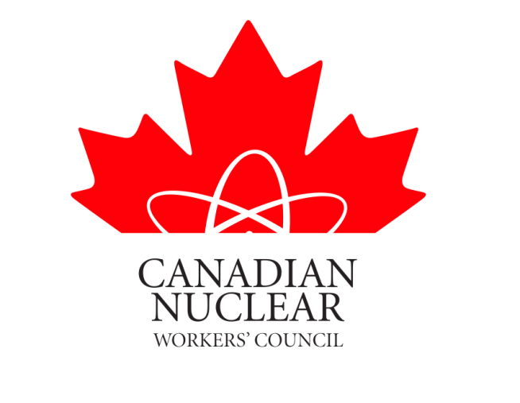
CANADIAN NUCLEAR WORKERS COUNCIL SUBMISSION

TO

THE STANDING COMMITTEE ON ENVIRONMENT & SUSTAINABLE DEVELOPMENT

IN REGARDS TO

THE CANADIAN ENVIRONMENTAL ASSESSMENT ACT (CEAA) REVIEW

NOVEMBER 24, 2011

The Canadian Nuclear Workers Council (CNWC) was founded in 1993 as an umbrella organization of Unions to represent workers in all sectors of the Canadian nuclear industry. Please see Appendix A for the list of member Unions and the purpose and objectives of the Council.

The 2010 Federal Budget made welcome improvements to the federal environmental assessment regime. We understand that the Standing Committee on the Environment is looking at a review of the Canadian Environmental Assessment Act and we wish to provide you with the views of the CNWC members as you prepare for that process.

Our member Unions insist on the highest standards for the health and safety of their members, their members’ families and the communities in which they live. Good safety performance results in good environmental safety. We fully believe that workplace safety and protection of the environment go hand in hand.

A growing demand for emissions-free electricity has powered tens of thousands of high-skill, high-paying jobs and contributed to economic development in communities across the country. Our industry, from mining to clean electricity generation, is poised for even more growth in the future.

The CNWC is concerned about how long it takes to get the approval to start these projects. Delays as we have seen in the past delay bringing the hundreds of long-term jobs connected to them, on stream. From our experience being involved with environmental assessments conducted by the CNSC on behalf of CEAA we have seen duplications, delays etc. in the process.

We believe there are opportunities to improve the process for environmental assessments without reducing standards or compromising the overall level of environmental protection.

During your committees deliberations in this regard we encourage you to look at changes to the act that will not only provide greater certainty on the timeliness of the EA process, but also increase co-ordination among federal government departments and between the federal and provincial governments.

Please consider the views of our members when this important legislation is reviewed.

Respectfully submitted

David Shier – President CNWC

